**Steps of Programming on Snap! in Bangla**

1. **Open any Web Browser, e.g. Internet Explorer or FireFox or Google Chrome, or Safari**
2. **On the Address Bar , type in:** [**http://snap.berkeley.edu/snapsource/snap.html**](http://snap.berkeley.edu/snapsource/snap.html)
3. **Click on the Wheel, as shown below**

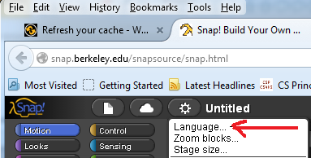

1. **Slect বাংলা, as shown below**

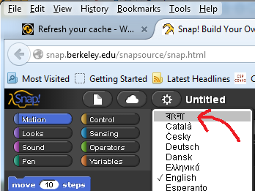

1. **By Dragging the blocks, Start Programming on Snap! in Bangla, as shown below**

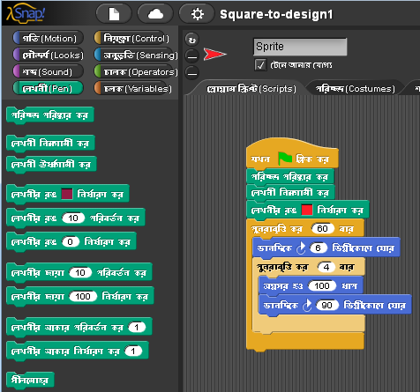

1. **Clcik on the Green Flag on the Upper-Right Corner, as shown below**

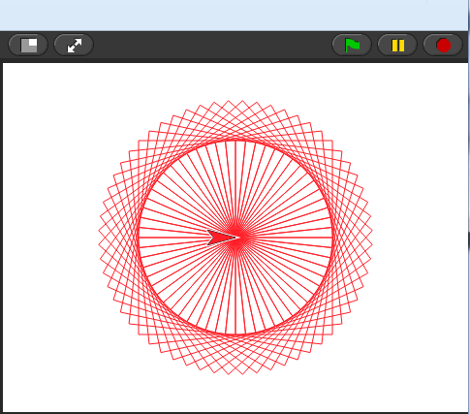

1. **You will see the Program Output, as shown above**

**PS. For more Programming Instructions and Example on Snap! in Bangla, Please Stay Tune with:** [**https://www.facebook.com/dr.mokter**](https://www.facebook.com/dr.mokter)

[**https://icterguru.appspot.com/snapbangla/**](https://icterguru.appspot.com/snapbangla/)

**(Coming Soon!!)**